Lab Assignment #4B
Cryptography

Steffen L. Norgren <ironix@trollop.org>
A00683006

COMP 7615 • BCIT • November 3, 2009

Table of Contents
Purpose 3
Procedures 3
1.1. Histogram Analysis of the Data Encryption Standard 3
1.2. Avalanche Effect 6
1.3. Triple DES (3-DES) 8
Discussion 12
1.1. Histogram Analysis of the Data Encryption Standard 12
1.2. Avalanche Effect - Question #1 12
1.2. Avalanche Effect - Question #2 13
1.3. Triple DES (3-DES) - Question #1 13
1.3. Triple DES (3-DES) - Question #2 14
1.3. Triple DES (3-DES) - Question #3 14
1.3. Triple DES (3-DES) - Question #4 14
1.3. Triple DES (3-DES) - Question #5 15
Conclusion 15

Purpose
To observe the difference in patterns when using DES (ECB) and 3-DES (ECB) encryption methods with different cipher keys and texts.

Procedures

1.1. Histogram Analysis of the Data Encryption Standard
The unencrypted text:
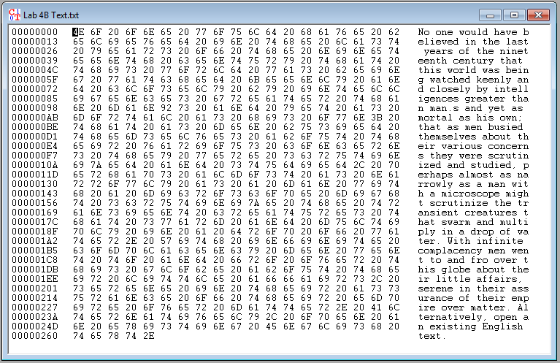

Histogram of unencrypted text:
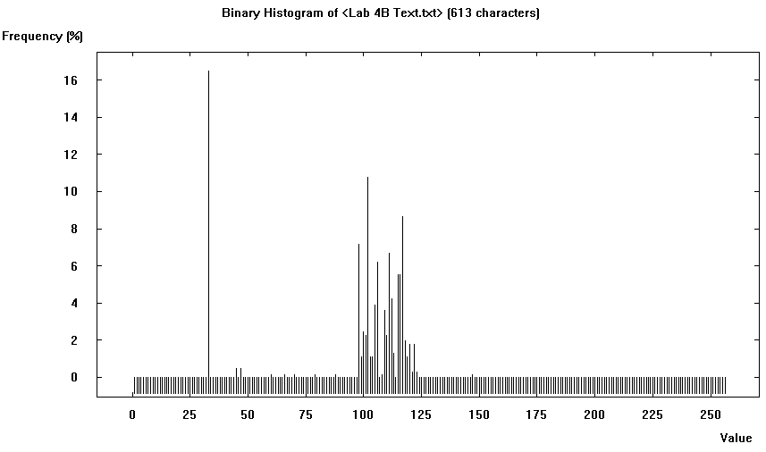
Encrypt the text using DES (CBC):
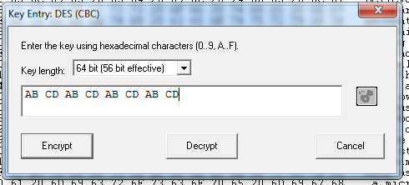

Encrypted text:
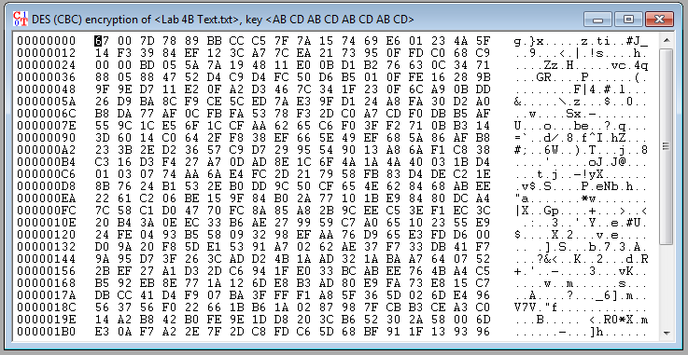
Histogram of encrypted text:
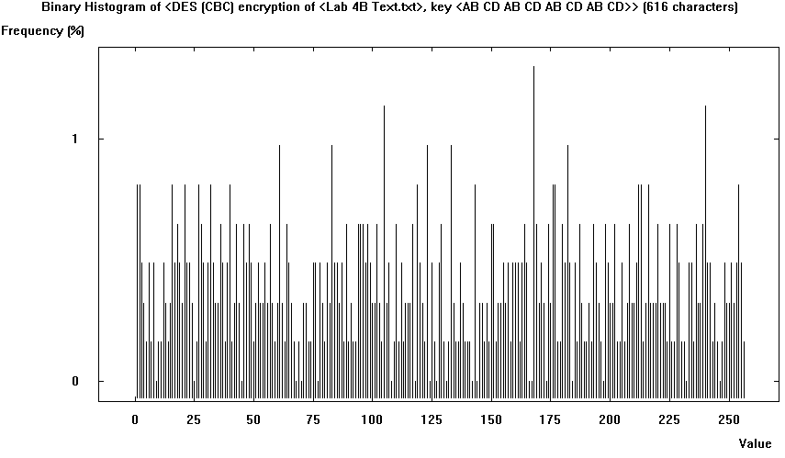

1.2. Avalanche Effect
Two plain texts with a single bit difference.
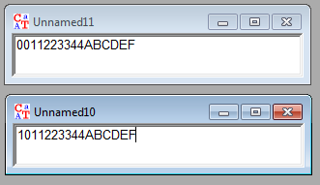
Encrypt both texts using the same key:
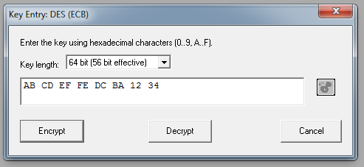
Both texts encrypted using the same key:
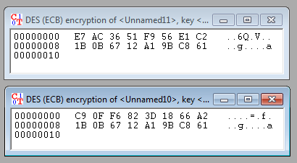
Single text encrypted using a key with a single bit difference.
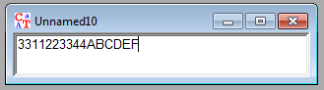
Encrypted using the following keys:
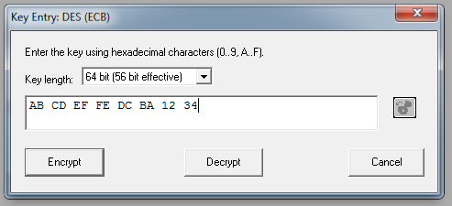
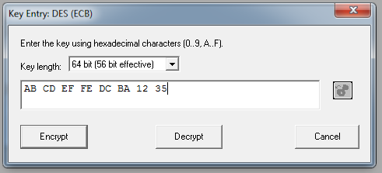
Results in the following encrypted texts:
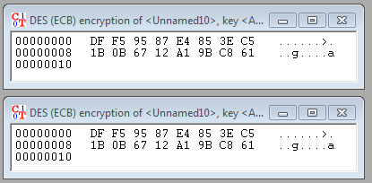

1.3. Triple DES (3-DES)
The source text to be encrypted:
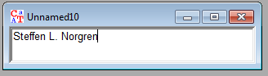
Encrypt using two different 3-DES ECB mode keys:
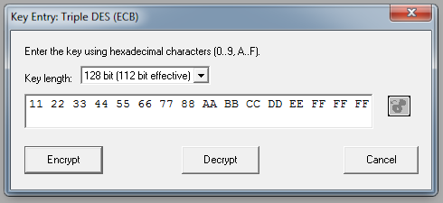
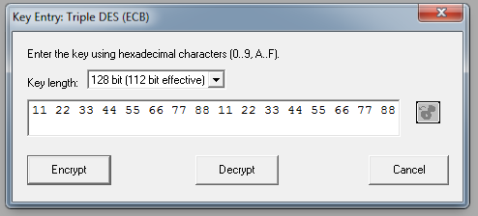

This results in the following encrypted texts:
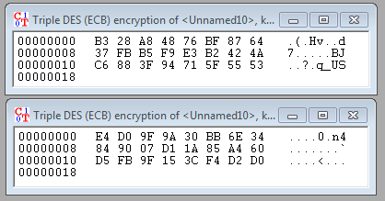
Decryption of an encrypted text where 64-bit long segments have been swapped:
Source text:
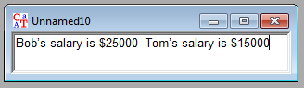
Encrypt using DES ECB:
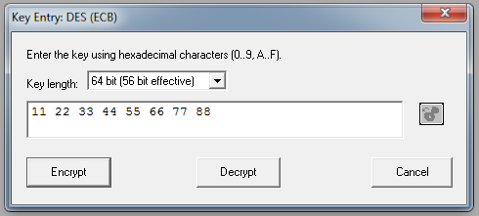
Results in the following encrypted text:
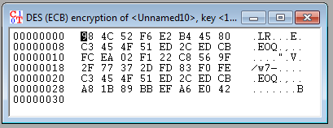
Swapping C1 with C4:
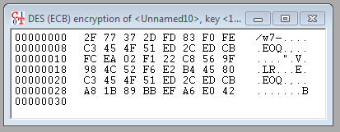
Decrypting using the same key results in the following text:
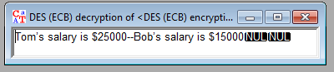

Discussion

1.1. Histogram Analysis of the Data Encryption Standard
When we look at the histogram for the unencrypted text, we can see that all the bits are clustered into a specific range, the ASCII alphabet, with a few exceptions that correspond to punctuation and spaces within the text.
After encrypting the text, we see that the bit frequency has been spread throughout the entire ASCII range. In addiction to this, we can no longer easily identify any real patterns in the encrypted text or its histogram.

1.2. Avalanche Effect - Question #1
When we encrypt two texts with a single bit difference using the same encryption key, we get the following result:
We can see in this example that the first 64-bit block of both encrypted texts are different; however, the second 64-bit block for each encrypted texts are identical. This is because the text is encrypted in 64-bit blocks and the difference between each text resides within the first 64-bit block, causing the second block for each text to remain the same.
This weakness opens up the door for cryptanalysts to discover the cipher key used to encrypt both texts.

1.2. Avalanche Effect - Question #2
When working with a single source text, but two different encryption keys that only differ by a single bit (the last bit), we end up with the following encrypted texts:
Doing an analysis of the actual bits in each text shows that they are identical. The reason for this is because the only difference in the encryption key was the very last bit. Since only the first 56-bits of the key are effectively used in DES ECB encryption, the single bit difference results in no differences between the two encrypted texts.

1.3. Triple DES (3-DES) - Question #1
When k1 = k2 or k2 = k3, Triple DES is reduced to single DES, and this is often used to provide backward compatibility. However, in this particular example we have the following key:
K = 11 22 33 44 55 66 77 88 AA BB CC DD EE FF FF FF
Which becomes the following when split up into 3 64-bit segments:
k1 = 11 22 33 44 55 66 77 88
k2 = AA BB CC DD EE FF FF FF
k3 = 11 22 33 44 55 66 77 88
And we can see that k1 != k2 or k2 != k3, meaning we cannot decrypt this particular message with key K.

1.3. Triple DES (3-DES) - Question #2
Out of the following keys:
K1 = 11 22 33 44 55 66 77 88 AA BB CC DD EE FF FF FF
K2 = 11 22 33 44 55 66 77 88 11 22 33 44 55 66 77 88

Only K2 will work for decryption using 1-DES. Using the first half of K2 we get the following decrypted text:

1.3. Triple DES (3-DES) - Question #3
M = Bob’s salary is $25000--Tom’s salary is $15000
Message M breaks up in the following 64-bit segments:
M1 = Bob’s sa
M2 = lary is
M3 = $25000--
M4 = Tom’s sa
M5 = lary is
M6 = $15000

1.3. Triple DES (3-DES) - Question #4
The cipher text blocks for message M after encrypted is as such:
C1 = 98 4C 52 F6 E2 B4 45 80
C2 = C3 45 4F 51 ED 2C ED CB
C3 = FC EA 02 F1 22 C8 56 9F
C4 = 2F 77 37 2D FD 83 F0 FE
C5 = C3 45 4F 51 ED 2C ED CB
C6 = A8 1B 89 BB EF A6 E0 42

1.3. Triple DES (3-DES) - Question #5
Exchanging C1 with C4 results in the following blocks:
C1 = 2F 77 37 2D FD 83 F0 FE
C2 = C3 45 4F 51 ED 2C ED CB
C3 = FC EA 02 F1 22 C8 56 9F
C4 = 98 4C 52 F6 E2 B4 45 80
C5 = C3 45 4F 51 ED 2C ED CB
C6 = A8 1B 89 BB EF A6 E0 42
Decrypting the above using the same key we used for encryption, results in the following output text:
We can see that we ended up swapping “Bob's sa” with “Tom's sa”. This was possible because we are encrypting and decrypting the text using 64-bit blocks. Swapping the blocks around will not change how subsequent blocks are decrypted using the DES ECB cipher.

Conclusion
Though the above analysis, we can see that there are weaknesses in both the DES and 3-DES encryption protocols. However, these weaknesses are usually only exposed when using extremely similar keys or texts, opening up avenues for cryptanalysts to work backwards to obtain the original encryption key.

